**Profit and Loss statement**

The user on the other hand just needs to be in a position to understand what the maker has prepared. He is just the user of the financial statements. He need not really know the details of the journal entries or the audit procedure.

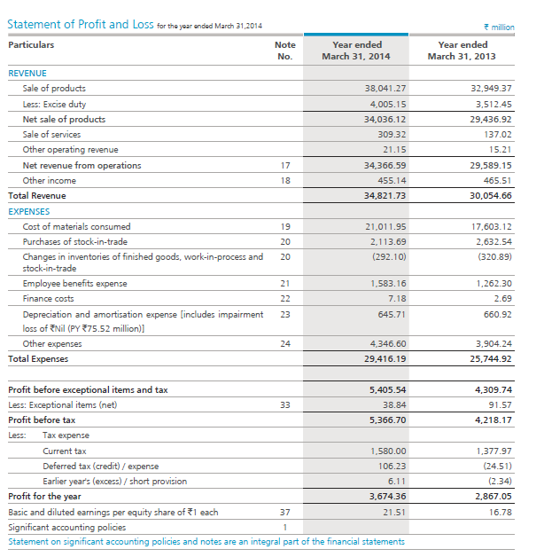

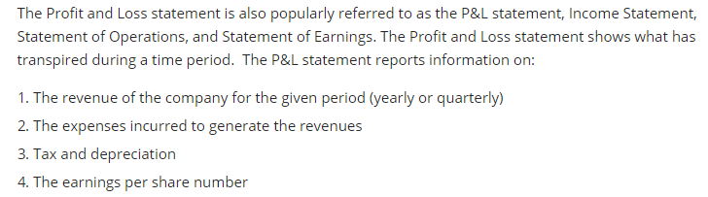

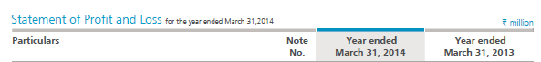

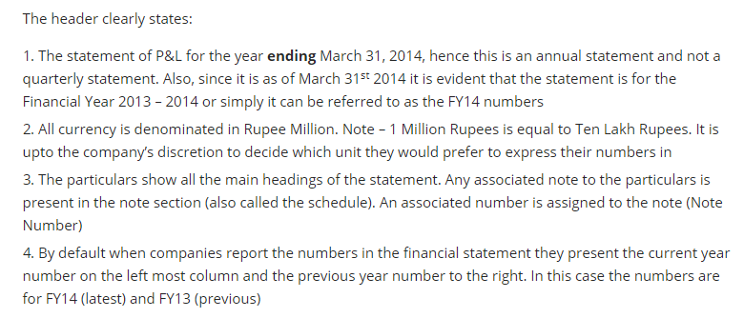

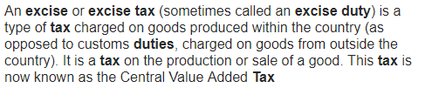

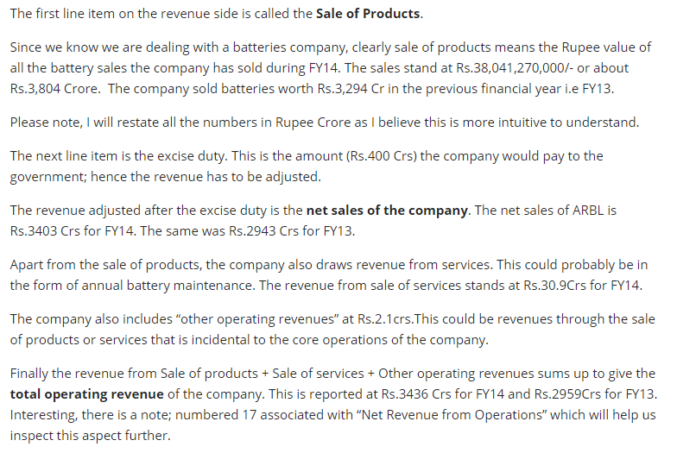

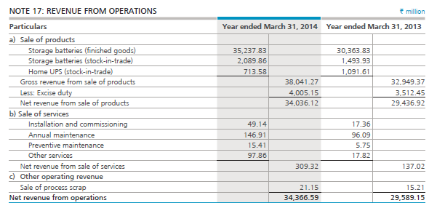

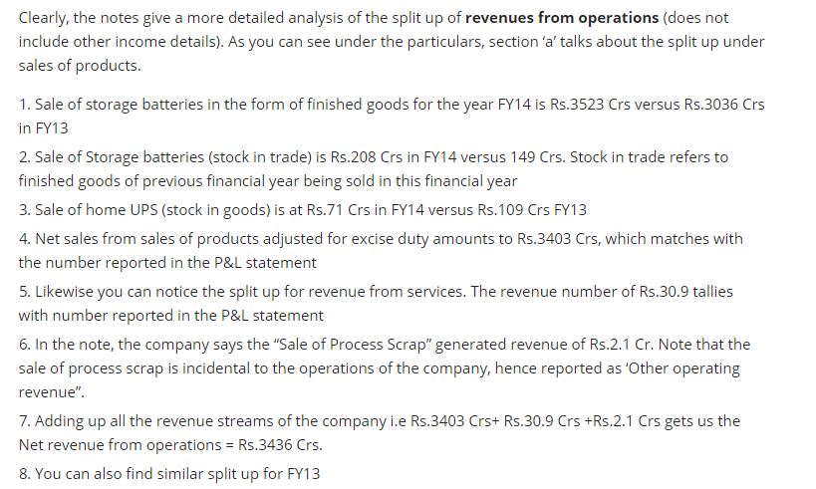

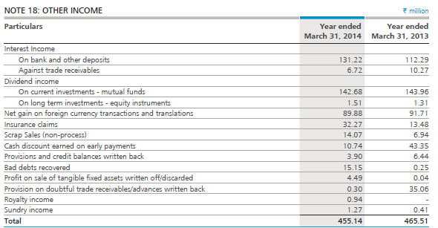

As we can see the other income includes income that is not related to the main business of the company. It includes interest on bank deposits, dividends, insurance claims, royalty income etc.

**Expense:-**

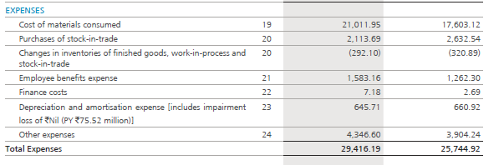

Almost every expense has note

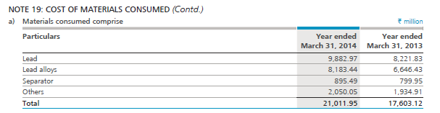

The first line item on the expense side is ‘Cost of materials consumed’; this is invariably the cost of raw material that the company requires to manufacture finished goods. The company uses lead, lead alloys, separators and other items all of which adds up to Rs.2101 Crs.

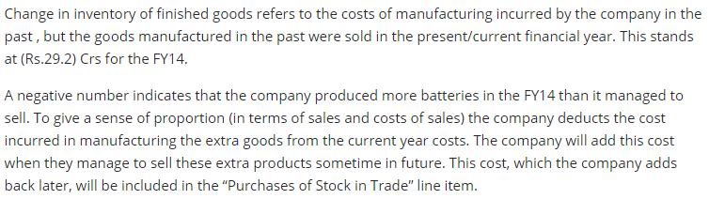

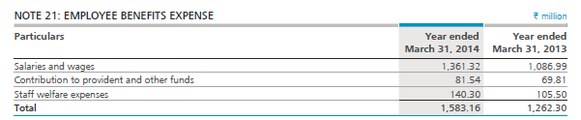

A company generating Rs.3482 Crs is spending only Rs.158 Crs or just 4.5% of its sales on its employees.

Finance cost is interest costs and other costs that an entity pays when it borrows funds. The interest is paid to the lenders of the company. The lenders could be banks or private lenders.

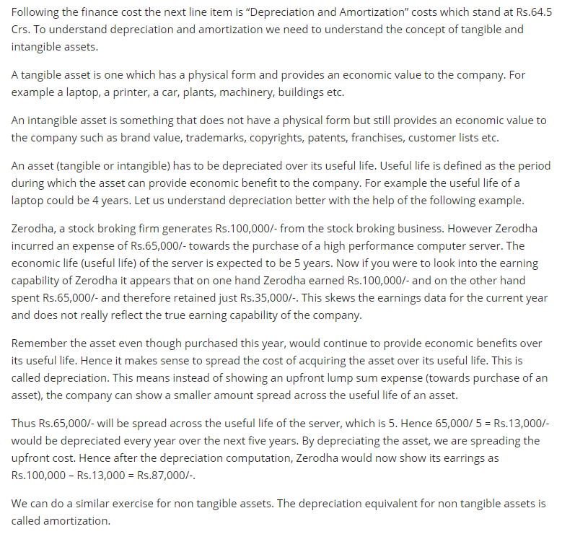



## The Profit before tax(PBT)

## 

## Profit before Tax = Total Revenues – Total Operating Expenses

## Net Profit after tax(PAT)

## Net **PAT = PBT – Applicable taxes**

## Current tax is the corporate tax applicable for the given year.

## 

## The last line in the P&L statement talks about basic and diluted earnings per share. The EPS is one of the most frequently used statistics in financial analysis. EPS also serves as a means to assess the stewardship and management role performed by the company directors and managers. The earnings per share (EPS) is a very sacred number which indicates how much the company is earning per face value of the ordinary share. It appears that ARBL is earning Rs.21.51 per share.

## The company indicates that there are 17,08,12,500 shares outstanding in the market. Dividing the total profit after tax number by the outstanding number of shares, we can arrive at the earnings per share number.

## Rs.367.4 Crs divided by 17,08,12,500 yields Rs.21.5 per share

EPS = PAT / Total number of outstanding ordinary shares

## at this stage we have just understood how to read the P&L statement, but we still need to analyze what the numbers mean. We will do this when we take up the financial ratios. Also, the P&L statement is very closely connected with the other two financial statements i.e the balance sheet and the cash flow statement.